ELEMENTS

In data and statistics, an "element" typically refers to a single member of a population or dataset. For example, if you are studying the heights of people in a certain country, each individual person's height would be an element of the population.

Elements can also refer to data points or values in a sample. For instance, if you take a random sample of 100 people from the population of the same country and measure their heights, each person's height measurement in the sample would be an element of the sample data.

In summary, an element in data and statistics refers to a single observation or value within a population or dataset that is being studied or analyzed.

VARIABLES

In data and statistics, a variable is a characteristic or attribute of an individual or object that can be measured or observed and can vary from one individual or object to another.

Variables can be classified into two broad categories: categorical and quantitative. Categorical variables represent qualities or characteristics that do not have an inherent numerical value, such as gender, marital status, or eye color. Quantitative variables, on the other hand, represent numerical values that can be measured, such as height, weight, age, or income.

Quantitative variables can be further divided into two categories: discrete and continuous. Discrete variables are counted in whole numbers and can only take certain values, such as the number of children in a family. Continuous variables can take on any value within a certain range, such as height or weight.

Variables are typically used in statistical analysis to identify relationships between different attributes, to make predictions or to identify patterns in data.

OBSERVATIONS

In data and statistics, an observation refers to a single unit of data that has been measured or observed. It is a specific instance or measurement of a variable for a particular individual or object.

For example, if you are collecting data on the heights of students in a class, each student's height measurement would be an observation. Similarly, if you are collecting data on the number of cars passing through an intersection each hour, each hour's count would be an observation.

Observations can be represented as rows in a dataset, with each column representing a different variable being observed. The number of observations in a dataset depends on the size of the population being studied and the sampling method used.

Observations are used in statistical analysis to identify patterns, relationships, and trends in data. By analyzing multiple observations of the same variable, statisticians can draw conclusions about the population as a whole.

SCALES OF MEASUREMENT:

In statistics, there are four different scales of measurement: nominal, ordinal, interval, and ratio. These scales determine the types of statistical analysis that can be performed on the data.

1. Nominal Scale: The nominal scale is the most basic level of measurement, and is used for variables that have categories or names that cannot be ranked. Examples of nominal variables include gender, race, or favorite color.
2. Ordinal Scale: The ordinal scale is used for variables that have categories or names that can be ranked, but the differences between the categories cannot be measured in a meaningful way. Examples of ordinal variables include academic grades (A, B, C, D, F) or socioeconomic status (low, middle, high).
3. Interval Scale: The interval scale is used for variables that have categories or names that can be ranked, and the differences between the categories have meaning. However, there is no true zero point. Examples of interval variables include temperature (in Celsius or Fahrenheit) or IQ score.
4. Ratio Scale: The ratio scale is the highest level of measurement, and is used for variables that have categories or names that can be ranked, the differences between the categories have meaning, and there is a true zero point. Examples of ratio variables include height, weight, or income.

The scale of measurement of a variable affects the type of statistical analysis that can be performed on the data. For example, certain statistical tests may only be appropriate for ratio data, while others may be appropriate for nominal or ordinal data.

differentiation between categorical and quantitative data

Categorical data and quantitative data are two types of data that are commonly used in statistical analysis. The main differences between these two types of data are:

1. Nature of data: Categorical data are non-numerical data that are typically represented by words or labels. They represent attributes or qualities that cannot be measured in numerical terms. Quantitative data, on the other hand, are numerical data that can be measured and expressed in numerical terms.
2. Measurement scales: Categorical data are typically measured on nominal or ordinal scales. Nominal scales are used to classify data into categories or groups based on some attribute or characteristic. Ordinal scales are used to order data based on some attribute or characteristic. Quantitative data are typically measured on interval or ratio scales. Interval scales measure the distance between values, but do not have a true zero point. Ratio scales have a true zero point and allow for meaningful ratios to be calculated.
3. Statistical analysis: Different statistical techniques are used to analyze categorical and quantitative data. Categorical data are typically analyzed using chi-square tests, contingency tables, or measures of association such as Cramer's V or Kendall's tau. Quantitative data are typically analyzed using measures of central tendency, measures of variability, correlation coefficients, or regression analysis.
4. Variables: Categorical data are often referred to as nominal or ordinal variables, whereas quantitative data are referred to as interval or ratio variables. Nominal variables have no inherent order, while ordinal variables have a defined order. Interval variables have a defined order and equal distances between values, while ratio variables have a true zero point and allow for meaningful ratios to be calculated.
5. Visual representation: Categorical data are often represented using bar charts, pie charts, or frequency tables. Quantitative data are often represented using histograms, box plots, or scatter plots.
6. Data transformation: Categorical data can be transformed into quantitative data by assigning numerical values to the categories, but these numerical values do not have any inherent meaning or value. Quantitative data can also be transformed into categorical data by grouping the values into categories or ranges.
7. Interpretation: The interpretation of categorical and quantitative data also differs. Categorical data can be interpreted in terms of frequencies, proportions, or percentages. Quantitative data can be interpreted in terms of measures of central tendency, variability, or correlation.

CROSS SECTIONAL DATA

Cross-sectional data is a type of research design in which data is collected from a sample of individuals or groups at a single point in time. This data is collected from a single snapshot or cross-section of the population, and does not follow individuals or groups over time.

For example, if a survey is conducted to gather information on the attitudes of people towards a certain product, and data is collected from a sample of individuals at a specific point in time, this would be considered cross-sectional data. Similarly, if a study is conducted to compare the health outcomes of individuals from different regions, and data is collected from a sample of individuals from each region at a specific point in time, this would also be considered cross-sectional data.

Cross-sectional data is often used in social sciences, public health, marketing research, and other fields to analyze trends, relationships, and patterns in a population at a specific point in time. It is a cost-effective way to gather data quickly, and can provide valuable insights into the characteristics of a population. However, cross-sectional data has limitations, as it cannot capture changes over time or provide information about causality.

TIME SERIES DATA

Time series data is a type of data in which observations are collected at regular intervals over time. This type of data is commonly used in fields such as economics, finance, engineering, and environmental science to study patterns, trends, and relationships over time.

Time series data typically consists of a single variable measured at multiple time points, such as stock prices over time, monthly sales figures, or daily temperature readings. The time intervals between each observation can be regular or irregular, and can range from seconds to years. Time series data can be represented graphically as a line chart, with the time variable plotted on the x-axis and the variable of interest plotted on the y-axis.

One important characteristic of time series data is its autocorrelation, which refers to the correlation between successive observations. Autocorrelation can affect the accuracy of statistical analyses, as it violates the assumption of independence required by many statistical tests. Therefore, time series data is often analyzed using specialized statistical techniques that take into account the time-dependent nature of the data, such as autoregressive models, moving averages, or exponential smoothing.

Time series data can be used to forecast future values of a variable, identify trends and seasonal patterns, or analyze the effects of interventions or external factors over time. It is a powerful tool for understanding the behavior of complex systems over time and can provide valuable insights for decision-making in a wide range of fields.

Differentiation between cross-sectional and time-series data

1. Definition: Cross-sectional data represent a snapshot of a population or group of individuals at a specific point in time. In contrast, time-series data represent observations that are collected over time at regular intervals.
2. Nature of data: Cross-sectional data include information on different individuals or units at a specific point in time. Time-series data, on the other hand, include information on a single individual or unit over time.
3. Analysis: Different statistical techniques are used to analyze cross-sectional and time-series data. Cross-sectional data can be analyzed using descriptive statistics or inferential statistics, such as chi-square tests or regression analysis. Time-series data, on the other hand, require time-series analysis techniques, such as forecasting, trend analysis, or autocorrelation.
4. Visual representation: Cross-sectional data are often represented using bar charts, pie charts, or scatter plots. Time-series data are often represented using line graphs or time plots.
5. Variables: In cross-sectional data, the variables of interest are typically independent variables that are used to explain variation in a dependent variable. In time-series data, the variable of interest is typically the dependent variable that is observed over time.
6. Sampling: In cross-sectional data, individuals or units are usually selected using a random sampling technique. In time-series data, observations are typically collected at fixed intervals over time, and the sample size may vary depending on the length of the time period.
7. Data collection: Cross-sectional data can be collected through various methods, such as surveys, interviews, or observations. Time-series data are typically collected through automated data collection systems or through periodic manual measurements.
8. Units of analysis: In cross-sectional data, the unit of analysis is usually the individual or the group that is being studied. In time-series data, the unit of analysis is typically a single variable that is observed over time.
9. Interpretation: The interpretation of cross-sectional and time-series data also differs. Cross-sectional data can be used to estimate prevalence or incidence of a particular phenomenon at a specific point in time. Time-series data, on the other hand, can be used to identify trends, patterns, or changes in a variable over time.
10. Hypothesis testing: In cross-sectional data, hypotheses are often tested to determine if there is a relationship between the independent and dependent variables. In time-series data, hypotheses are often tested to determine if there is a significant change or trend in the dependent variable over time.

DESCRIPTIVE STATISTICS

Descriptive statistics are a set of statistical tools used to summarize and describe the basic features of a data set. These statistical methods help to provide an overview of the data, identify patterns and relationships, and provide a basis for making inferences about the population from which the data is drawn.

There are several types of descriptive statistics, including measures of central tendency, measures of variability, and measures of shape. Some commonly used descriptive statistics include:

1. Mean: The arithmetic average of a set of numerical data.
2. Median: The middle value in a set of numerical data, such that half the values are above and half are below it.
3. Mode: The value that occurs most frequently in a set of data.
4. Range: The difference between the largest and smallest values in a set of data.
5. Standard deviation: A measure of the spread of a data set around the mean.
6. Skewness: A measure of the asymmetry of a data set around its mean.
7. Kurtosis: A measure of the peakedness or flatness of a data set around its mean.

Descriptive statistics can be used to provide a quick summary of a data set, or to compare different data sets to each other. They are also used as a starting point for more advanced statistical analyses, such as inferential statistics, which are used to draw conclusions about a population based on a sample of data.

STATISTICAL INFERENCE

Statistical inference is the process of using sample data to make generalizations about a population. It involves making estimates, predictions, and decisions based on a subset of data in order to draw conclusions about the larger group from which the data is drawn.

In statistical inference, the goal is to use the information in the sample to infer or make conclusions about the larger population from which the sample is drawn. This involves the use of probability theory, statistical models, and hypothesis testing to make inferences about the population.

Statistical inference can be divided into two main categories: estimation and hypothesis testing. Estimation involves using the sample data to estimate a population parameter, such as the mean or proportion, along with a measure of uncertainty or error. Hypothesis testing involves making a decision about whether a particular hypothesis about the population is supported by the sample data.

The accuracy and reliability of statistical inference depends on the quality of the sample and the assumptions made about the population being studied. Random sampling and the use of appropriate statistical models and methods can help to ensure that the results of statistical inference are valid and reliable.

Statistical inference is an important tool in many fields, including social sciences, medicine, engineering, and business, and is used to make informed decisions based on data and evidence.

**TABULAR summarizing categorical data**

Tabular methods are a popular way to summarize categorical data. In a tabular summary, the data is organized into a table with rows representing the categories and columns representing summary statistics. The most common tabular summary for categorical data is a frequency table, which shows the number of observations in each category.

For example, consider a survey in which participants were asked to select their favorite color from a list of options. The data can be summarized in a frequency table as follows:

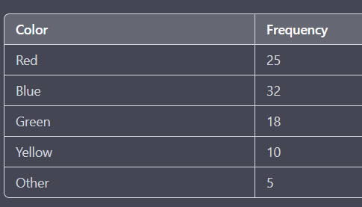

In this table, the categories are the different color options and the frequency column shows the number of participants who selected each color. The table provides a quick and easy way to see the distribution of responses and identify any patterns or trends.

Other tabular summaries for categorical data include relative frequency tables, which show the proportion or percentage of observations in each category, and contingency tables, which show the frequency or proportion of observations in two or more categorical variables.

**GRAPHICAL summarizing categorical data**

Graphical methods are another popular way to summarize and present categorical data. There are several types of graphs that are commonly used to display categorical data, including:

1. Bar charts: A bar chart is a graph that displays categorical data using rectangular bars, where the height of each bar represents the frequency or proportion of observations in each category. Bar charts are useful for comparing the distribution of data across different categories.
2. Pie charts: A pie chart is a circular graph that displays the relative sizes of different categories as proportions of the whole. Each category is represented by a slice of the pie, where the size of the slice corresponds to the proportion of observations in that category.
3. Stacked bar charts: A stacked bar chart is a variation of a bar chart that displays the frequency or proportion of observations in each category, broken down by subcategories. Each bar is divided into segments, where the height of each segment represents the proportion of observations in that subcategory.
4. Pareto charts: A Pareto chart is a combination of a bar chart and a line graph, where the bars are displayed in descending order of frequency or proportion, and a cumulative line graph shows the cumulative frequency or proportion of observations.

Graphical methods are particularly useful for presenting categorical data in a visually appealing and easy-to-understand way. They can help to highlight patterns and trends in the data and make it easier to compare different categories or subcategories. However, it is important to choose the appropriate type of graph based on the nature of the data and the research question being addressed.

SUMMARIZING QUANTITATIVE DATA

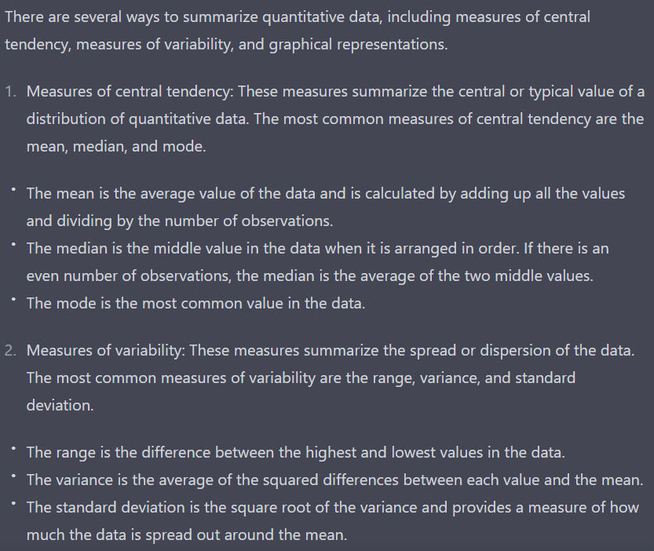

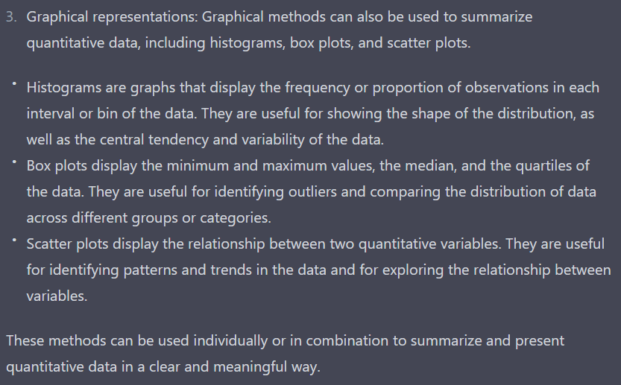

CROSS TABULATION

Cross-tabulation, also known as contingency table analysis or cross-tab, is a statistical technique used to analyze the relationship between two categorical variables. It involves creating a table that displays the frequency or proportion of observations that belong to each combination of categories for the two variables.

For example, consider a survey in which participants were asked to rate their satisfaction with a product on a scale from 1 to 5, and also indicate whether they had previously purchased the product. A cross-tabulation table for these two variables might look like this:

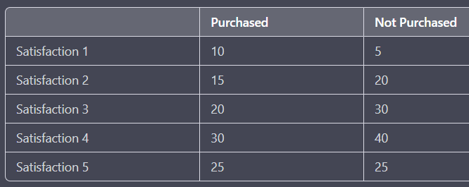

In this table, the rows represent the satisfaction ratings and the columns represent whether the participant had previously purchased the product. The numbers in the table represent the frequency or proportion of participants in each combination of categories. For example, there were 30 participants who rated their satisfaction as 4 and had previously purchased the product.

Cross-tabulation is useful for exploring the relationship between two categorical variables and identifying any patterns or trends in the data. It can also be used to test for independence between the variables using statistical tests such as the chi-square test.

SCATTER DIAGRAM

A scatter diagram, also known as a scatter plot, is a graph that displays the relationship between two quantitative variables. It is used to explore the relationship between the variables and identify any patterns or trends in the data.

The scatter diagram consists of a grid where the x-axis represents one variable and the y-axis represents the other variable. Each point on the graph represents the value of both variables for one observation in the data. The position of the point on the graph corresponds to the values of the two variables for that observation.

For example, consider a study that examines the relationship between a person's age and their income. A scatter diagram for this data might look like this:

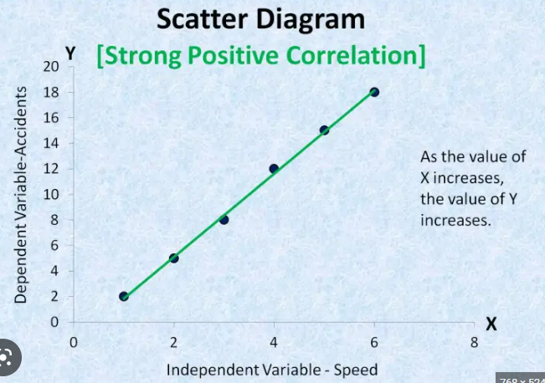

In this graph, each point represents the income and age of one person in the study. The x-axis represents age, and the y-axis represents income. The position of each point on the graph shows the income and age for that person.

A scatter diagram can be used to identify patterns in the data such as a linear relationship, a curvilinear relationship, or no relationship at all. It can also be used to identify outliers, which are observations that fall far from the pattern seen in the rest of the data. Additionally, a line of best fit can be added to the graph to estimate the trend in the data and make predictions for values that are not in the dataset.

MEASURES OF LOCATION

Measures of location are statistics used to describe the central tendency or typical value of a dataset. There are several measures of location, including the mean, median, and mode.

**Mean:** The mean is the most commonly used measure of location. It is the sum of all the values in the dataset divided by the number of observations. It represents the "average" value of the dataset. However, the mean can be heavily influenced by outliers, which are values that are much higher or lower than the rest of the data.

**Median:** The median is the middle value in a dataset when the values are arranged in order. It represents the value that separates the dataset into two equal parts, with half of the observations above and half below the median. The median is less sensitive to outliers than the mean, making it a more robust measure of location.

**Mode:** The mode is the value that occurs most frequently in a dataset. It represents the most common value in the dataset and is useful for identifying the most popular category in a categorical dataset.

Other measures of location include percentiles and quartiles, which divide the dataset into equal parts. For example, the first quartile (Q1) is the value that separates the lowest 25% of the data from the rest of the data, and the third quartile (Q3) is the value that separates the highest 25% of the data from the rest of the data. These measures are useful for identifying the spread or variability of the data.

MEASURES OF VARIABILITY

Measures of variability are statistics used to describe the spread or dispersion of a dataset. There are several measures of variability, including range, interquartile range (IQR), variance, and standard deviation.

**Range**: The range is the difference between the maximum and minimum values in a dataset. It is a simple measure of variability but is highly influenced by outliers.

**Interquartile range (IQR):** The IQR is the difference between the first quartile (Q1) and the third quartile (Q3) in a dataset. It represents the spread of the middle 50% of the data and is less sensitive to outliers than the range.

**Variance:** The variance is the average of the squared differences from the mean of each value in the dataset. It measures how much the observations deviate from the mean and is highly influenced by outliers.

**Standard deviation:** The standard deviation is the square root of the variance. It measures the spread of the data in the same units as the original data and is the most commonly used measure of variability. It is also highly influenced by outliers.

Other measures of variability include mean absolute deviation (MAD) and coefficient of variation (CV). The MAD is the average of the absolute differences from the mean of each value in the dataset and is less sensitive to outliers than the standard deviation. The CV is the ratio of the standard deviation to the mean and is useful for comparing the variability of datasets with different scales or units.

MEASURES OF DISTRIBUTION SHAPE

Measures of distribution shape are statistics used to describe the shape of a frequency distribution. There are several measures of distribution shape, including skewness and kurtosis.

Skewness: Skewness measures the degree of asymmetry of a frequency distribution. A distribution is considered to be symmetric if it is evenly distributed around its mean, with roughly equal numbers of values on either side of the mean. A positively skewed distribution has a longer right tail, meaning that the values on the right side of the distribution are more spread out than the values on the left side. A negatively skewed distribution has a longer left tail, meaning that the values on the left side of the distribution are more spread out than the values on the right side.

Kurtosis: Kurtosis measures the degree of peakedness or flatness of a frequency distribution. A distribution with high kurtosis has a sharp peak and heavy tails, meaning that there are many values near the mean and relatively few values far from the mean. A distribution with low kurtosis has a flat peak and light tails, meaning that there are fewer values near the mean and more values far from the mean.

There are different formulas for calculating skewness and kurtosis, but some of the most commonly used include Pearson's moment coefficient of skewness, which measures the degree of skewness based on the mean, median, and standard deviation, and Fisher's coefficient of kurtosis, which measures the degree of kurtosis based on the fourth moment of the distribution. Histograms and box plots are commonly used graphical tools for visualizing the shape of a frequency distribution.

RELATIVE LOCATION

Relative location refers to the position of a data point in relation to other data points in a dataset. It is typically measured in terms of percentiles, which divide a dataset into 100 equal parts. The percentile of a data point represents the percentage of values in the dataset that are equal to or less than that data point. For example, if a student's score on a test is at the 90th percentile, it means that the student performed better than 90% of the other students who took the test.

Commonly used percentiles include the median (50th percentile), quartiles (25th and 75th percentiles), and deciles (10th, 20th, 30th, etc., percentiles). These percentiles are often used to summarize the distribution of a dataset and provide information about the relative location of individual data points within that distribution.

The use of percentiles is particularly useful in cases where the dataset has outliers or extreme values that can skew the mean and standard deviation. In such cases, percentiles provide a more robust measure of relative location that is less sensitive to the presence of outliers.

DETECTING OUTLIERS

Detecting outliers is an important step in analyzing data as they can significantly affect the results of statistical analyses. Outliers are data points that are significantly different from other data points in a dataset and may be due to measurement errors, data entry errors, or other unusual circumstances.

There are several methods for detecting outliers:

**Visual inspection:** One of the simplest ways to detect outliers is to visually inspect the data using graphs such as histograms, box plots, and scatter plots. Outliers often appear as data points that are far away from the bulk of the data.

**Z-score:** The Z-score is a statistical measure that indicates how many standard deviations a data point is away from the mean of the dataset. Typically, data points that have a Z-score greater than 3 or less than -3 are considered to be outliers.

**Interquartile range (IQR):** The IQR is a measure of the spread of the middle 50% of the data in a dataset. Data points that fall outside the range of 1.5 times the IQR below the first quartile or above the third quartile are considered to be outliers.

**Mahalanobis distance:** The Mahalanobis distance is a statistical measure that takes into account the correlation between variables in a dataset. It is a more advanced method for detecting outliers and can be useful in datasets with multiple variables.

Once outliers have been identified, it is important to decide what to do with them. In some cases, outliers may be due to genuine data points that should not be removed. However, in other cases, outliers may be due to errors or other unusual circumstances and should be removed or corrected before further analysis.

BOX PLOT

A box plot, also known as a box-and-whisker plot, is a graphical representation of the distribution of a dataset. The box in the plot represents the middle 50% of the data (i.e., the interquartile range), and the whiskers represent the range of the data outside the box.

To construct a box plot, the data is first divided into quartiles. The bottom of the box represents the first quartile (Q1), which is the 25th percentile of the data. The top of the box represents the third quartile (Q3), which is the 75th percentile of the data. The middle line in the box represents the median, which is the 50th percentile of the data.

The whiskers extend from the top and bottom of the box to the highest and lowest data points that are within 1.5 times the interquartile range (IQR) of the box. Any data points that are outside this range are considered outliers and are plotted as individual points.

Box plots are useful for comparing the distributions of different datasets and for identifying outliers. They can also provide information about the symmetry and skewness of the data. A symmetric distribution will have a box that is roughly centered between the whiskers, while a skewed distribution will have a box that is closer to one whisker than the other.

MEASURE OF ASSOCIATION BETWEEN TWO VARIABLES

Measures of association are statistical techniques used to quantify the strength and direction of the relationship between two variables. There are several measures of association, each of which is appropriate for different types of variables and research questions. Here are some commonly used measures of association:

**Pearson's correlation coefficient:** This measures the linear relationship between two continuous variables. The correlation coefficient ranges from -1 to +1, with values close to -1 indicating a strong negative relationship, values close to +1 indicating a strong positive relationship, and values close to 0 indicating little or no relationship.

**Spearman's rank correlation coefficient:** This measures the monotonic relationship between two variables, which means that it does not assume a linear relationship. Instead, it measures the extent to which the values of one variable increase or decrease in tandem with the values of the other variable. It is appropriate for ordinal or continuous variables.

**Kendall's rank correlation coefficient:** This measures the strength of the rank-order relationship between two variables. Like Spearman's rank correlation, it does not assume a linear relationship and is appropriate for ordinal or continuous variables.

**Chi-squared test:** This measures the association between two categorical variables. It compares the observed frequencies in a contingency table to the frequencies that would be expected if the variables were independent. A significant chi-squared value indicates that the variables are associated.

**Cramer's V:** This is a measure of the strength of association between two categorical variables. It is based on the chi-squared test and ranges from 0 to 1, with values closer to 1 indicating a stronger association.

**Point biserial correlation coefficient:** This measures the association between a continuous variable and a dichotomous variable. It is calculated as the Pearson correlation coefficient between the continuous variable and a dummy variable representing the dichotomous variable.

The choice of measure of association depends on the types of variables being analyzed and the research question of interest.